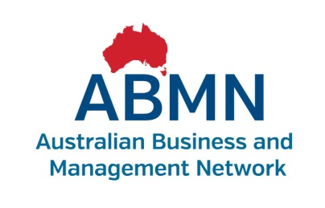
Learning Program Outline
Qualification or Unit name and code | BSB30211 Certificate III in Customer Contact  Module 1 – Customer Service  BSBCUS301B Deliver and monitor a service to customers  BSBCMM301B Process customer complaints
Partnership arrangements | Considered Training & Assessment (CTA) are the Registered Training Organisation (RTO), we will be partnering with for this qualification.  Contact: Tony Smith, Training Manager
ABMN Soft Skills Program title | NA
Description of learner requirements/needs and characteristics | There are 10 learners participating in a traineeship - Certificate III in Customer Contact.  In the workplace the learners’ are involved in considerable client contact, usually inbound and outbound telephone calls.  Some of the group already have Certificate II qualifications in business or related areas. Other team members do not have any formal qualifications but have quite a bit of experience working in customer contact.
How the program will address learner needs | The program has been developed on a module by module basis to take the learners through their basic KPIs.
Timeline - sessions – intervals – completion | This program will take 6-12 months to complete. The qualification (12 units) has been broken up into five modules. Each module will be delivered over several weeks with assessment by the RTO on completion of each module.  There will be regular intervals between modules.  The number of sessions per module is to be determined by the facilitator, but is likely to be up to four 1-hour sessions for some modules.  Module 1 – Customer Service will be delivered over at least two, 1-hour training sessions.
Delivery mode | Classroom 1-hour group sessions supported by one-on-one supervisor meetings, time off-the-job to complete activities, and RTO assessment after the completion of each module.
Reasons for delivery mode | Supported by the RTO and suits the working environment at Head Office.
Main resources and equipment | PowerPoints from previous training  Training Room (seats up to 15)
Induction requirements | NA
Assessment requirements | NA
Language, literacy and numeracy (LLN) requirements of the program | Some of the learners have attained formal qualifications, however, around 30% of this team left school early and have not completed a senior school certificate. As they are inexperienced learners there may be some LLN issues to consider in your planning. It is suggested the sessions and resources for this group be simple, at least initially, until a full review of the learners has been undertaken.
Special needs | One participant, Jeremy White uses a wheelchair. Melanie Purton has some visual impairment and copes well with larger text and audio wherever possible.

Learning Program – Plan & Timeline
SESSION & DATE | TOPIC (Unit grouping name) | REFERENCE TO PROGRAM (i.e. Performance Criteria, Skill, Knowledge component) | RESOURCES REQUIRED
Module 1  Dates to be determined | Customer Service | 1.BSBCUS301B Deliver and monitor a service to customers  2.BSBCMM301B Process customer complaints  - Identify customer needs  - Deliver a service  - Monitor and report service delivery  - Respond to complaints  - Refer complaints  - Exercise judgement  See unit guides for further information on skills and knowledge. | Session Plans, PowerPoint presentations, classroom activities

